Lab Exercise 4: Using Conversion Functions and Conditional Expressions

By using HR Schema in Oracle Express Edition, answer the following SQL questions.

1. Produce the SQL that have a result as shown. (1 Mark)

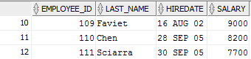

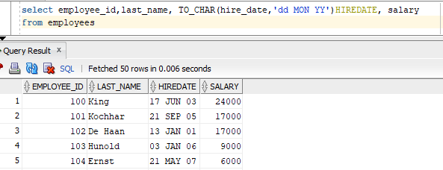

1. Produce the SQL that follows the following result. (1 Mark)

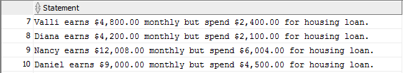

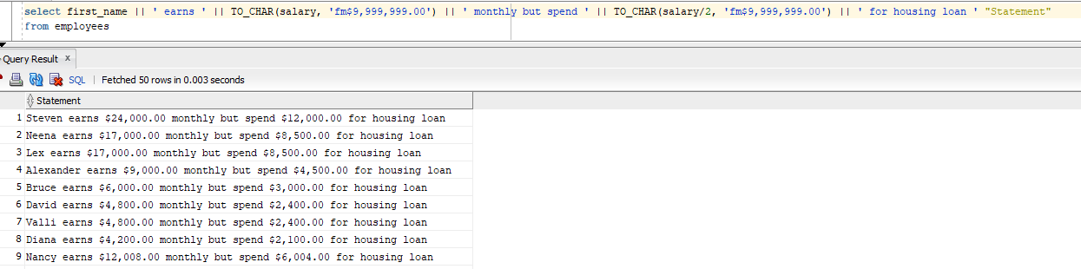

1. Find the employees from department 50 that are hired after 2004. (1 Mark)

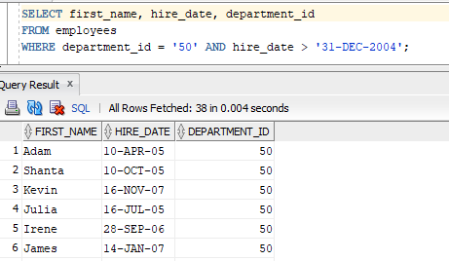

1. Find all the employees that have no manager and make sure to put ‘No Manager’ as a display to null value. (1 Mark)

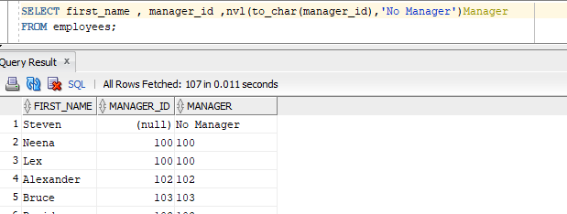

1. Find the departments that ends with ‘ng’ and indicate with ‘Yes’ or ‘No’ for Manager_ID column. ‘Yes’ is for department with manager, and ‘No’ is for department with no manager. (1 Mark)

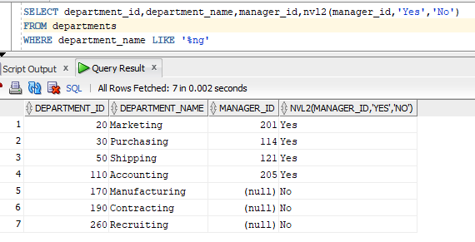

1. Find whether the employees first name have an equal length with their last name. (1 Mark)

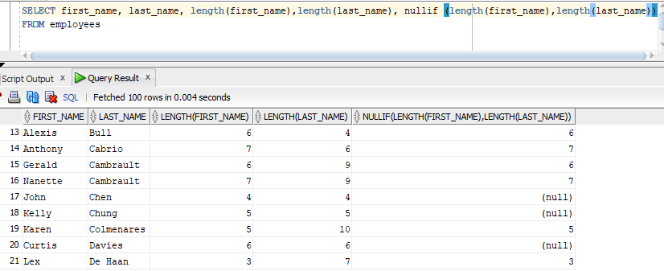

1. Find the employee ID and last name, salary, commission and manager. By using COALESCE function, if the commission and manager is null, display ‘No Manager and Commission’. If not, display either commission, followed by manager ID. (1 Mark)

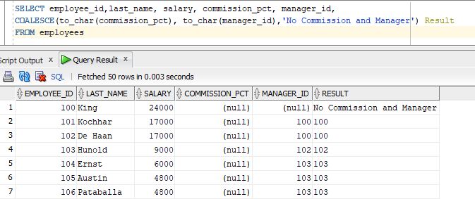

1. BY using DECODE function, write a query that displays the salary of all employees based on the value of the JOB_ID column, using the following data:

|  |  |
| --- | --- |
| **JOB_ID** | **SALARY INCREMENT** |
| FI_ACCOUNT | 10% |

|  |  |
| --- | --- |
| IT_PROG | 20% |
| SA_REP | 25% |
| PU_CLERK | 24% |
| None of the above | 40% |

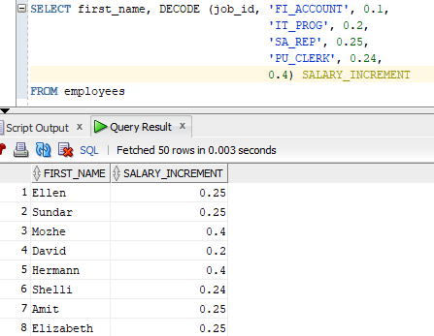

1. Rewrite the code by using CASE function. (1 Mark)

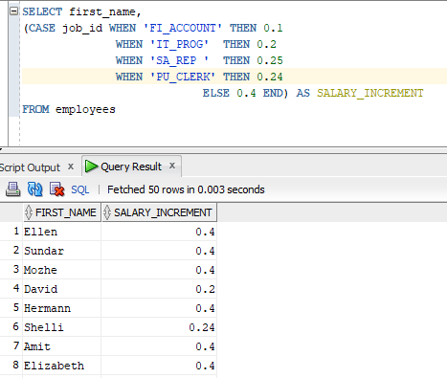

1. Have you started your group project work? (1 Mark)

AHAHAHHA not yet :c